
Online edition of India's National Newspaper
Sunday, Mar 01, 2009
http://www.hindu.com/2009/03/01/stories/2009030156970300.htm
Date:01/03/2009 URL: http://www.thehindu.com/2009/03/01/stories/2009030156970300.htm

New Delhi
A feast of music
Photo: V.V.Krishnan
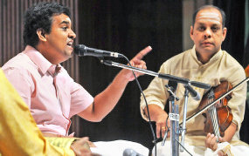
Maharajapuram Ganesh Viswanathan rendering a Carnatic vocal recital accompanied by Mullaivasal G. Chandramouli on the violin on the second day of the four-day Thyagaraja Music Festival organised by Sree Shanmukhananda Sangeetha Sabha at Andhra Bhavan in New Delhi on Saturday.
© Copyright 2000 - 2008 The Hindu

